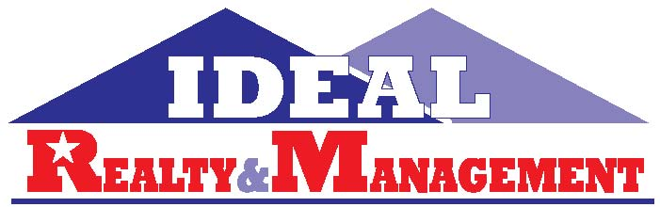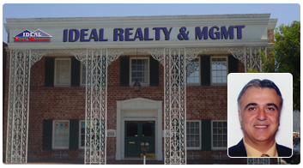
210 N Central Ave. Suite #100 Glendale, Ca 91203 P 818 247-7788 W www.irmandcocom
F 213 984 2653 Email INFO@NBSONE.COM
YOUR 1 STOP REAL ESTATE NEED

EVERYTHING YOU NEED TO KNOW ABOUT BUYING AND SELLING YOUR REAL ESTATE

Sponsored by: Ideal Realty & Mgmt. Haig Nashalian

Some of the topics will include:

Buying
Selling
Leasing/Renting
Loans
Management
Fees: No Charge FREE

Location:
- Our Business Location address above

To register, simply complete the registration form and fax or email to above information

Name: Telephone:

Address: Fax:

City Zip Code

Email

I am interested in ___Buying ____ Selling____ Leasing/Renting ____Managing my property

For My ___ House ___Apartment ___Commercial __ Industrial ___ Land ___ Business that I own
Ideal Realty & mgmt.. Inc. maintains an experienced and professional staff that holds the balanced value of customer service while telling clients what they have to hear and not just what they want to hear. We also follow our guarantee of ethics that all of our agents hold up to, and that is conducting actions in the utmost professional terms to endure satisfaction by our clients.

Our team is readily accessible via email, phone call, or in person to answer any questions or any concerns one might have regarding any real estate topics.

I would appreciate if you give us the opportunity to represent you on your next real estate transaction.

Thank you for your consideration and we hope to hear from you soon!

